**Aim: Capturing and analyzing network packets using Wireshark (Fundamentals):**

**- Identification the live network**

**- Capture Packets**

**- Analyze the captured packets**

1. Open Wireshark

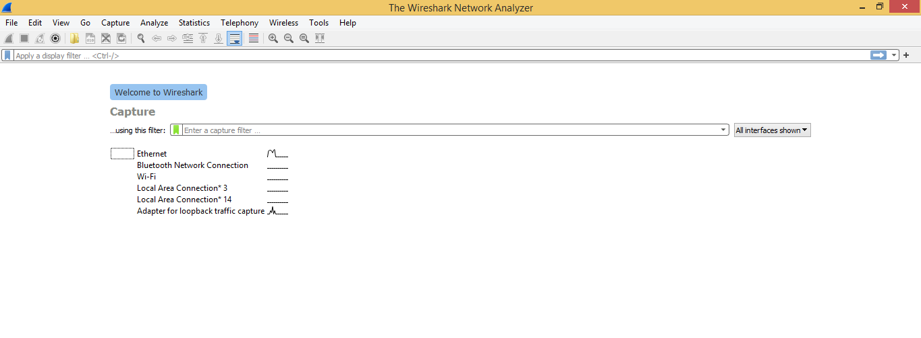

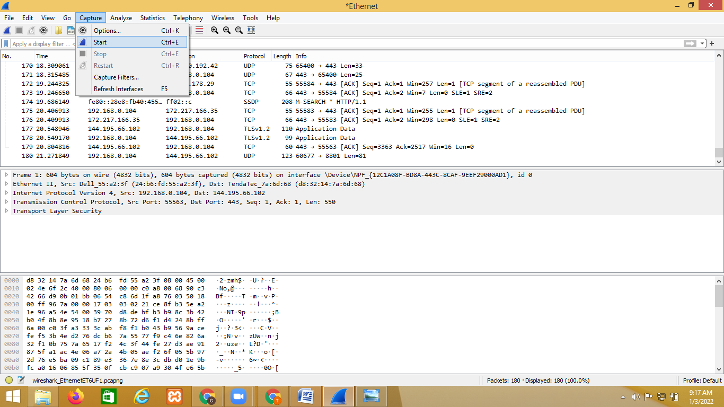

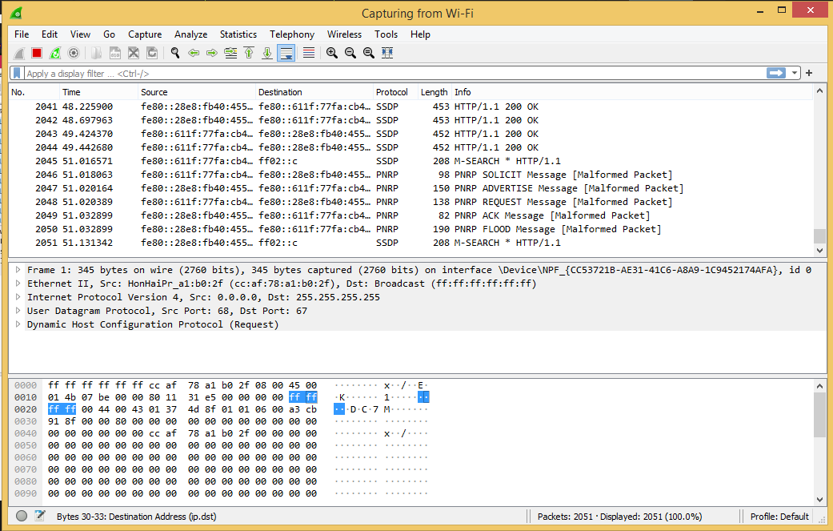

**TCP package: search TCP package**

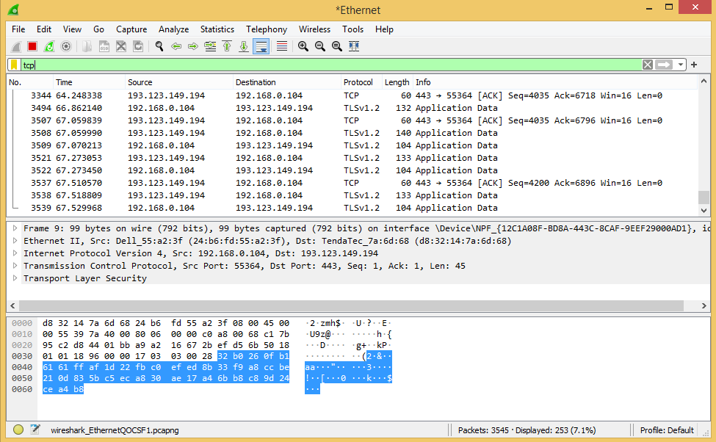

**Analysis youtube data**

Now go on browser and open youtube and perform some activity on the youtube

Now come back to Wireshark and enter **udp contains youtube** in the search bar.

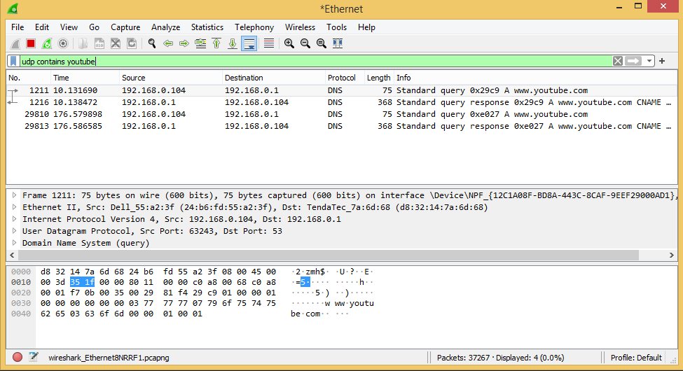

**search udp conyains user:** Now go on browser, login in any secured website and Now come back to Wireshark and enter **udp contains user** in the search bar.

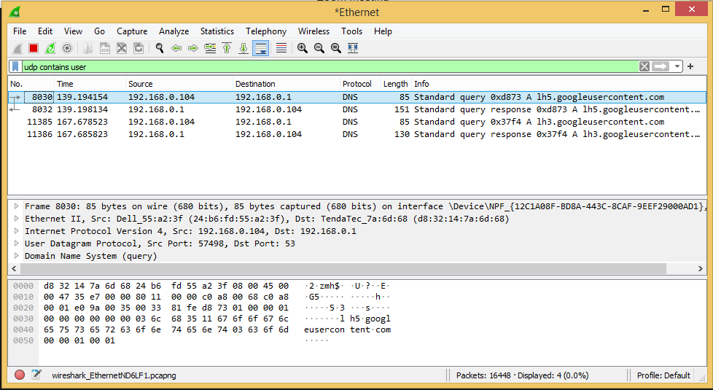

**http website:** go on browser, login in any unsecured website and Now come back to Wireshark and enter **http.request.method==POST** in the search bar.You can view the username and password because it is http website

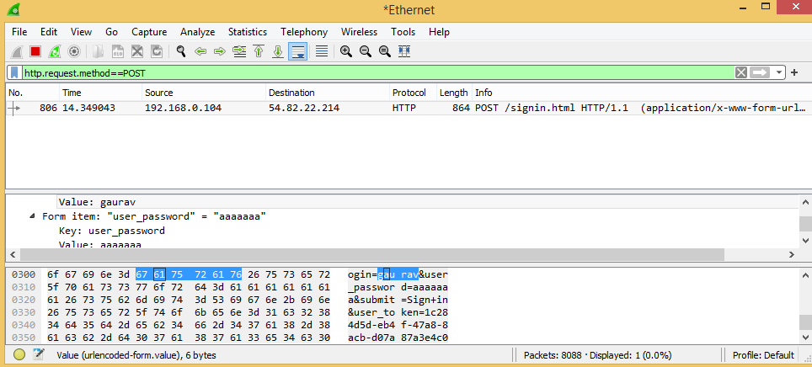

**filter with ip**: ip.addr==192.168.0.104

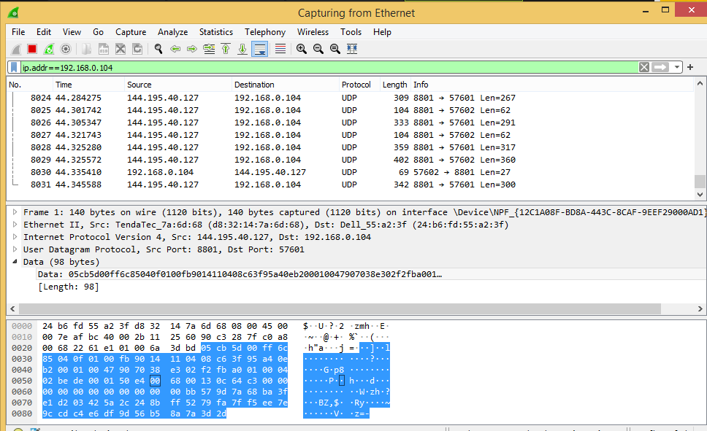

**filter udp package with length :** udp.length==100

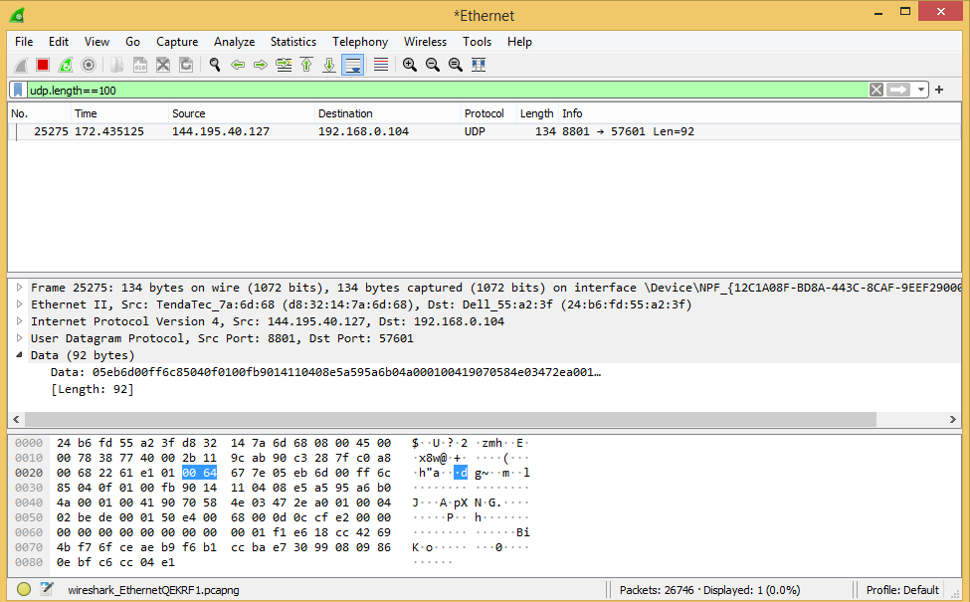

**Many other filter expression**

